2023 PRICE LIST
Rian Fabrication Services
Toll free (833) 238-8181
Facsimile (619) 655-4696
Text (619) 992-1742
2-1742

- Seamless Panel Liners in Raw, Primed or Fabric Covered
- Seamless FiberMats in Raw, Primed or Fabric Covered

- Twelve of the Most Popular Fabrics and Cork by the Yard
- Cork and Memo Boards in Raw, Primed or Fabric Covered
- Round, Oval and Odd Shaped Stretcher Frames
- Custom Shaped Hardwood Veneer Frames for Art or Mirrors
- Hardwood Veneer Shadowbox Frames
- Hardwood Veneer Float Frames
- Artist and Display Panels in Raw, Fabric Covered or Hardwood Veneer
- Custom Fabrication of Decorative Wood Products
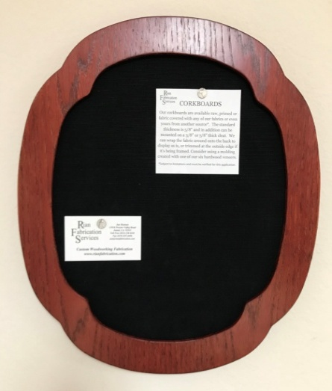
www.rianfabrication.com jan@rianfabrication.com
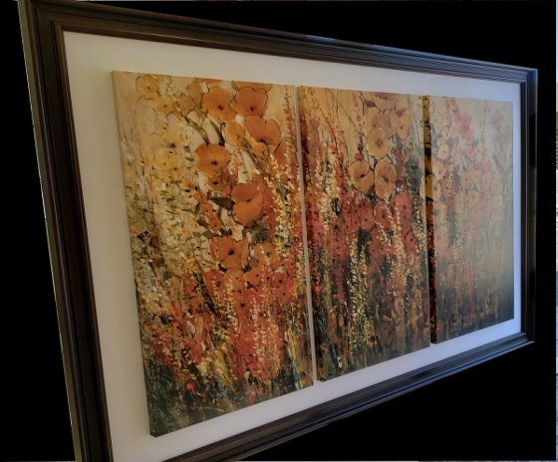
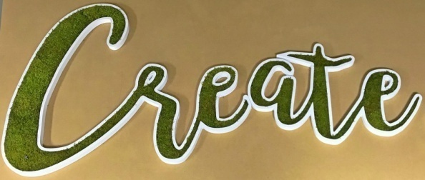

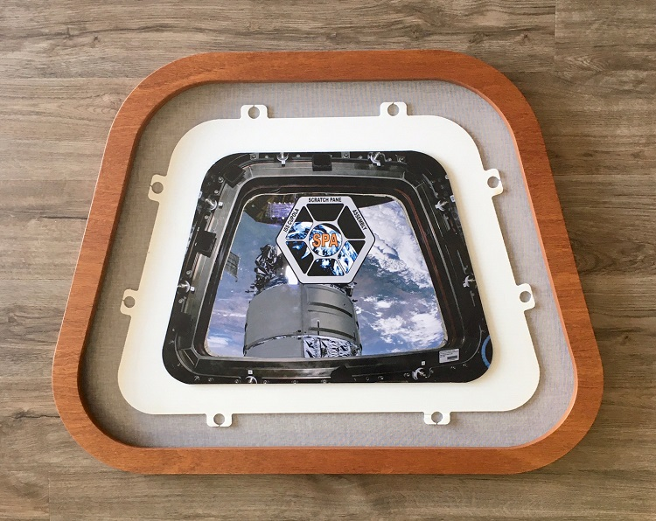
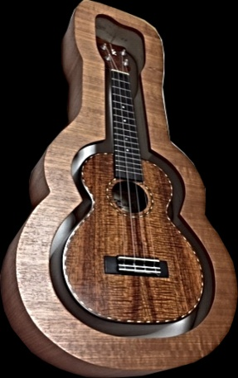
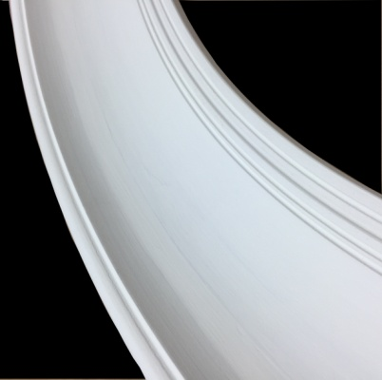

Fabric and Cork Priced Per Yard
1/2 Yard Minimum
Fabric | Description | Wide | Cut Yardage | 5 Yard | 10 Yard | 20 Yard | Bolt
Black | Linen/Cotton | 55" | $25.50 | $25.00 | $24.50 | $24.00 | $22.00
Blond | Linen | 58" | $24.50 | $24.00 | $23.50 | $23.00 | $21.00
Cream | Linen | 56" | $25.50 | $25.00 | $24.50 | $24.00 | $22.00
Ebony | Polished Cotton | 45" | $12.00 | $11.50 | $11.00 | $10.50 | $9.50
Flax | Linen | 56" | $26.50 | $26.00 | $25.50 | $25.00 | $23.00
Ink | Cotton Duck | 60" | $16.50 | $16.00 | $15.50 | $15.00 | $14.00
Ivory | Linen/Cotton | 56" | 25.50 | $25.00 | $24.50 | $24.00 | $22.00
Natural | Linen | 58" | $29.50 | $29.00 | $28.50 | $25.00 | $26.00
Oatmeal | Linen/Cotton | 57" | $25.50 | $25.00 | $24.50 | $24.00 | $22.00
Optic White | Linen | 55" | $29.50 | $29.00 | $28.50 | $28.00 | $26.00
Oyster | Linen/Cotton | 57" | $17.50 | $17.00 | $16.50 | $16.00 | $15.00
White | Linen | 57" | 27.50 | $27.00 | $26.50 | $26.00 | $24.00
Cork | 1/8" Cork | 48" | $25.80 | $21.50 | N/A | N/A | N/A

Seamless FiberMats and Panel Liners
Pricing per Outside United Inch - 24 UI Minimum on Raw & Primed 30 UI Minimum on Fabric Wrapped
Thickness |  | Raw | Primed | Rian* |  | Your** |  | Special***
1/8" MDF |  | $0.85 | $1.00 | $1.45 |  | $2.00 |  | $2.35
1/4" MDF |  | $0.85 | $1.00 | $1.45 |  | $2.00 |  | $2.35
3/8" MDF |  | $0.85 | $1.00 | $1.45 |  | $2.00 |  | $2.35
1/2" Ultralight |  | $0.95 | $1.15 | $1.60 |  | $2.20 |  | $2.55
5/8" Ultralight |  | $0.95 | $1.15 | $1.60 |  | $2.20 |  | $2.55 + $20
5/8" Scoop Ultra |  | N/A | N/A | $2.00 |  | $2.60 |  | $2.55
3/4" Ultralight |  | $1.05 | $1.25 | $1.60 |  | $2.20 |  | $2.55
3/4" Scoop Ultra |  | N/A | N/A | $2.00 |  | $2.80 |  | $2.55+ $20
1" Ultralight |  | $1.30 | $1.60 | $2.00 |  | $2.60 |  | $3.15
1" Scoop Ultra |  | N/A | N/A | $2.40 |  | $3.00 |  | $3.55 +$20
*You May Deduct $.10 per Outside United Inch for Providing us with Fabric from your own stock. Add $.30 to the Rian Price for your difficult Fabrics (silk, suede, faux silk)
**Your refers to Fabrics I order on your behalf, from any other supplier. ***Special refers to Silk, Suede and any other fabric, particularly hard to work with.
Pricing Includes the Cutting and Wrapping of One Standard Opening
Outside Sizes Over 48" x 48" Please Call for a Quote as OS Charges Apply
Additional Charges
Cut and Fabric Wrap Additional Openings In a FiberMat or Panel |  |  |  |  |  | $6.00
Fabric Wrap a Round Opening of Less than 16" in Diameter |  |  |  |  |  | $6.00
Fabric Wrap a Round Opening Greater than 16" in Diameter |  |  |  |  |  | $9.00
Fabric Wrap a Round Opening Greater than 50 UI |  |  |  |  |  | $16.00
Fabric Wrap a Complex Shape - Surcharge Starting At |  |  |  |  |  | $12.00
Wrap Fabric Around the Outside Perimeter onto the Back |  |  |  |  |  | $.10 Per OD UI
Extra Sanding and Priming - Per Coat Charge |  |  |  |  |  | $.20 Per OD UI
Design CAD Drawings for Complex Shapes and Openings |  |  |  |  |  | Starting at $30.00
Over-sized Packing Charge 1 - Over 60 United Inch of Package OD |  |  |  |  |  | $25.00
Over-sized Packing Charge 2 - Over 72 United Inch of Package OD |  |  |  |  |  | $45.00
Over-sized Packing Charge 3 - Over 108 Length & Girth Package OD |  |  |  |  |  | $60.00
Over-sized Packing Charge 4 - Two Dimensions Over 48 UI of Package OD |  |  |  |  |  | Starting at $100.00
Add Stabilizer Bars to Stretcher Frame or Over-sized Liners |  |  |  |  |  | Starting at $15.00

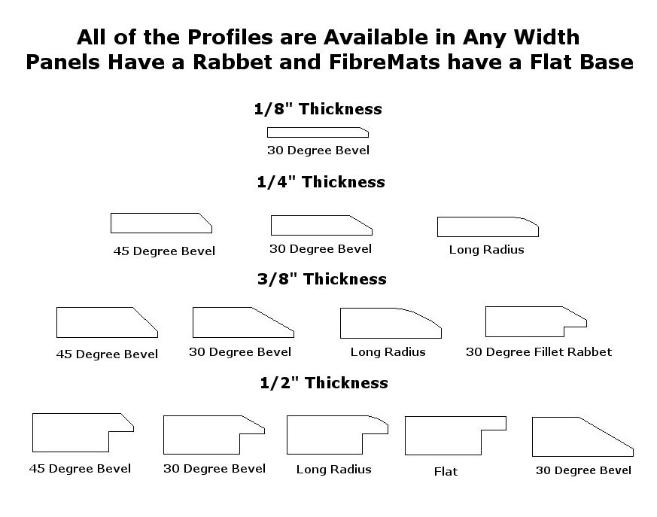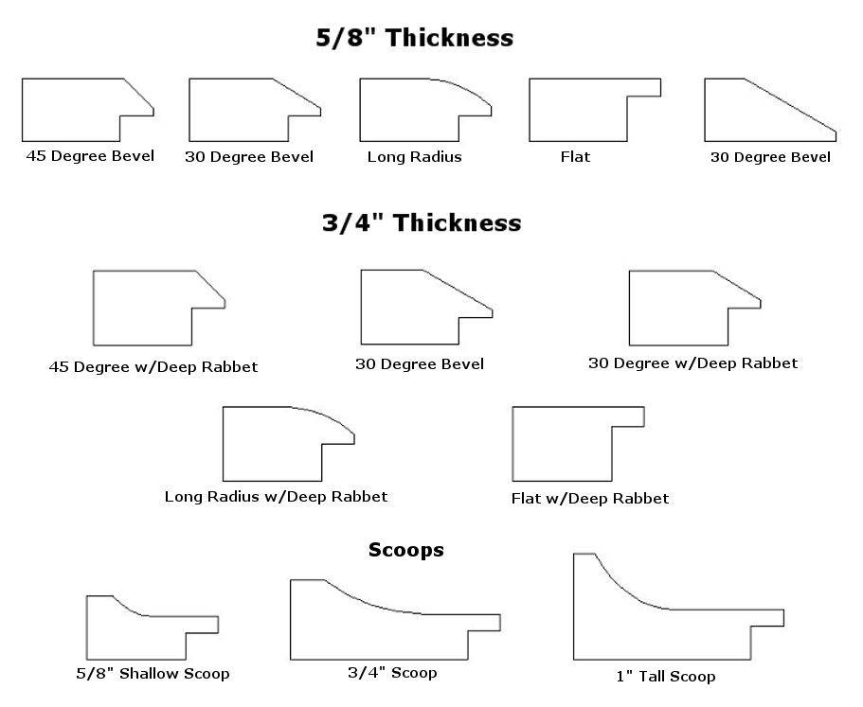

The very best part of Rian Fabrication Services is that, when dealing with us, you are not limited to a specific shape or profile. All of our Seamless Panel Liners (we use this term for anything with a rabbet) and FiberMats (for those without a rabbet) are available in any border width. Even the edge details that we included on our profile sheets are just a sampling of what we can produce. Everything we make is custom and we love special projects. Uneven borders, bottom weighting, deeper rabbets, Rounds, Ovals and just about anything you can imagine. Send us a sketch and let us help you create that one of a kind product to enhance your art.
Round, Oval & Other Shaped Stretcher Frames
Pricing Per Outside United Inch - 36 United Inch Minimum
Our Stretcher Frames are available in almost ANY SIZE and SHAPE
Just send a drawing of what you're looking for and we can almost always create it. Design fees may apply.

Profile | Thickness | Raw | Primed
A | 1" | $1.65 | $2.15
B | 1" | $1.65 | $2.15
C | 3/4" | $1.55 | $2.00
D | 1-1/2" | $2.30 | $2.80
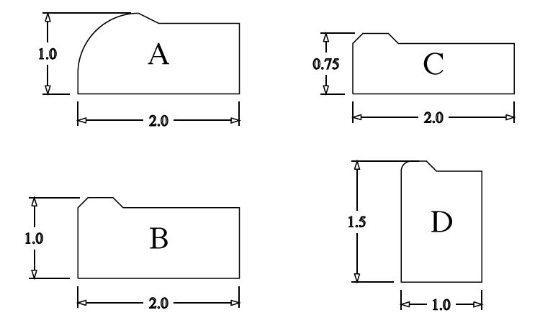
Standard Stretcher Frame Profiles Add $18.00 for Stabilizing Cross Bars
Custom Shaped Hardwood Veneer and Ultralight MDF Frames
Pricing per Outside United Inch - 24 United Inch Minimum
Unlike solid wood frames, we are not limited to a particular size, shape or depth. We start with our versatile Ultralight MDF and create one of a kind frames. We offer them raw or primed, for you to apply a finish coat, or laminated with any one of our beautiful hardwood veneers. We offer 6 stock species (see below) but we will gladly apply a stain of your choice using the Minwax Stain Chart for reference. This chart is available in most hardware stores. Our finished product includes two layers of semi-gloss urethane.
Material | Thickness | Raw | Primed
Ultralight MDF | Up to 1" | $1.60/UI | $2.00/UI
Ultralight MDF | Up to 1.5" | $1.95/UI | $2.70/UI
Add $.60 per United Inch for each Additional 1/2 Inch of Height

Onyx - Oak w/Wine - Walnut - African Mahogany - Maple - Cherry - Red Oak
Material | Height | Raw | Finished
Hardwood Veneer | Up to 1" | $2.10/UI | $2.40/UI
Hardwood Veneer | Up to 2" | $2.40/UI | $2.70/UI
Hardwood Veneer | Up to 3" | $2.70/UI | $3.00/UI
Hardwood Veneer | Up to 4" | $3.00/UI | $3.30/UI
Custom Shadow Box Frames
Pricing per Outside United Inch - 24 United Inch Minimum.
Our Custom Shadow Boxes have a 1-1/16" Top and a 3/4" Stem. Unlike other companies, they are available in any height
Material | Height | Raw | Finished
Hardwood Veneer | Up to 1" | $3.10/UI | $3.40/UI
Hardwood Veneer | Up to 2" | $3.40/UI | $3.70 UI
Hardwood Veneer | Up to 3" | $3.70/UI | $4.00/UI
Hardwood Veneer | Up to 4" | $4.00/UI | $4.30/UI
Hardwood Veneer | Up to 5" | $4.30/UI | $4.60/UI
Hardwood Veneer | Up to 6" | $4.60/UI | $4.90/UI
Add $.30 per United Inch for each Additional Inch of Height Fabric Wrapped and Hardwood Veneer Display Panels
Pricing per Outside United Inch - 24 United Inch Minimum

Your options are an endless variety of shapes, sizes and thicknesses. Let your imagination be your guide in creating that one of a kind base for your Shadow box with coordinating fabric covered or wood veneer side walls

Material | Thickness | Raw | Primed | Fabric Covered
Ultralight MDF | 3/4" | $.95/UI | $1.10/UI | $1.55/UI
Ultralight MDF | 1" | $1.20/UI | $1.85/UI | $2.35/UI
Ultralight MDF | 1.5" | $2.05/UI | $2.35/UI | $2.90/UI

Material | Thickness | Raw | Finished
Hardwood Veneer | 3/4" | $2.25/UI | $2.70/UI
Hardwood Veneer | 1" | $2.80/UI | $3.25/UI
Hardwood Veneer | 1.5" | $3.35/UI | $3.80/UI
Shadow Box Walls and Spacers
We also offer fabric covered side walls, either flat or wedged and
pin-wheeled or chopped and end-wrapped. $25 minimum. Add $15.00 to include a rabbet
Height | Raw | Primed | Fabric Covered
3/4" Spacer | $1.20/ft | $1.40/ft | $2.90/ft
3/4" Wedge | $1.55/ft | $1.75/ft | $3.25/ft
Up to 2" Spacer | $1.50/ft | $1.70/ft | $3.85/ft
Up to 2" Wedge | $1.85/ft | $2.05/ft | $4.20/ft
Up to 3" Spacer | $2.20/ft | $2.25/ft | $5.05/ft
Up to 3" Wedge | $2.45/ft | $2.50/ft | $5.40/ft

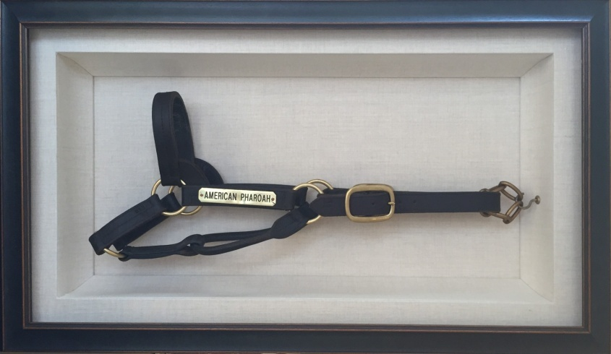
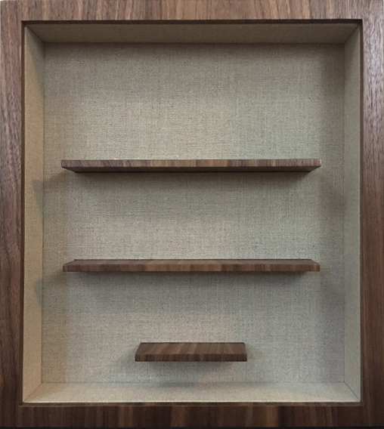
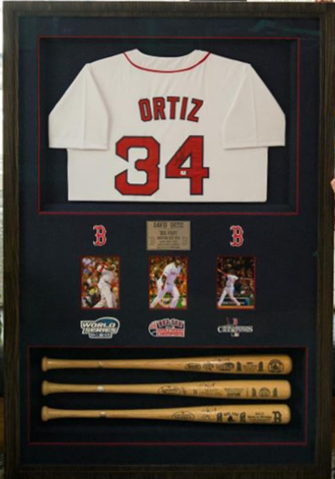
Add $.60 per foot/inch for Raw and Primed and $1.20/ft for Fabric
Custom Cork Boards
Pricing Per Square Inch - 500 Square Inch Minimum
Maximum Outside Diameter is 48" x 96"
In addition to raw cork, we offer three board thickness. The 5/8" thick cork board is intended for the projects which will be framed. When fabric is used, only the top of the cork board is covered. Both the 1" and the 1-1/4" cork boards are intended to be hung without a frame. A lifter is added which serves as a hanging cleat which simplifies the installation process. The fabric is wrapped around the edge of the board and on to the back of the lifter for a beautiful clean look. You can choose from any one of our ten fabrics or send us yours. We regularly have fabric drop shipped from Frank's Fabrics, at a discounted rate.

Description | Thickness | Price
1/8" Raw Cork on 1/2" Tackboard | 5/8" | 0.05
1/8" Primed Cork on 1/2" Tackboard | 5/8" | 0.06
1/8" Primed Cork on 1/2" Tackboard with Our Fabric | 5/8" | 0.10
1/8" Primed Cork on 1/2" Tackboard with Your Fabric | 5/8" | 0.08
1/8" Raw Cork on 1/2" Tackboard with 3/8" Lifter | 1" | 0.08
1/8" Primed Cork on 1/2" Tackboard with 3/8" Lifter | 1" | 0.09
1/8" Primed Cork on 1/2" Tackboard with a 3/8" Lifter and Our Fabric | 1" | 0.12
1/8" Primed Cork on 1/2" Tackboard with 3/8" Lifter and Your Fabric | 1" | 0.10
1/8" Raw Cork on 1/2" Tackboard with 5/8" Lifter | 1.25" | 0.10
1/8" Primed Cork on 1/2" Tackboard with 5/8" Lifter | 1.25" | 0.11
1/8" Primed Cork on 1/2" Tackboard with 5/8" Lifter and Our Fabric | 1.25" | 0.14
1/8" Primed Cork on 1/2" Tackboard with 5/8" Lifter and Your Fabric | 1.25" | 0.12
We also sell 1/8" thick Raw Cork at $25.00 per yard.

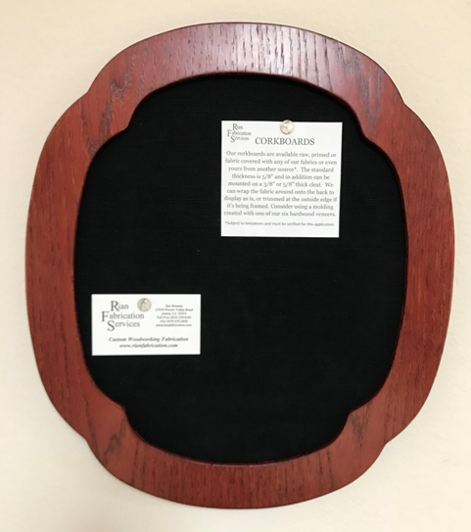
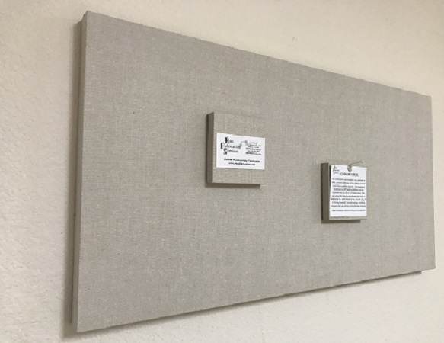
Think Outside the Box Because We Love Custom Projects

Custom Fabrication

In addition to the many products and services shown throughout this price list, one of our primary sources of business is custom wood fabrication for the decorating and hospitality industries. Our specialty is one of a kind projects that are usually used as wall décor or free standing sculptures. As a frame company, you have probably worked with decorators or designers in the past so our capabilities may open a whole new market for you. Typically, when approached by a designer looking to have a special project created, they send us a concept image or drawing. We respond with an estimated cost and if it is within their budget, we proceed with CAD drawings and material specifications which are then submitted for approval before moving forward. For a full brochure of our projects or for further information please contact us.

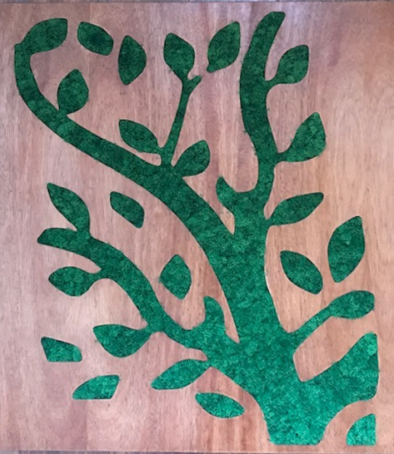
Moss inset in one of our versatile Hardwood Veneer Panels.
Maximum size is 4 foot by 8 foot.
No watering is necessary with this variety of Live Preserved Moss
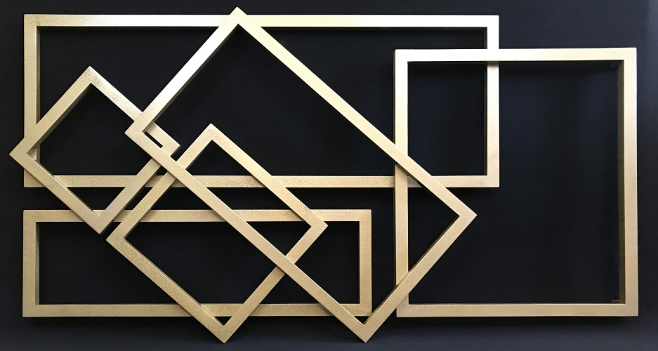

Hammered Gold Frames, stacked and assembled and then spray painted. How creative can you get? We offer this finish in gold and silver.

